Milford School Lunchtime meals procedure
If parents of children with special dietary requirements haven’t made meal choices in advance of the cut-off date for booking lunches online, they will need to provide a packed lunch for their child for the school week.
If children do not have special dietary requirements, best efforts will be made to provide them with a hot meal, but parents may be requested to provide a packed lunch for the week.
All children with any dietary requirements wear a blue wristband alongside their meal choice wristband. This ensures these children are clearly visible and meal choices can be checked.
Kitchen staff keep a photograph of each child with allergy or dietary requirements in a folder that is collected from, and returned to, a locked cupboard each day. This is an additional safeguard if there is any uncertainty over a child’s specific needs.
Kitchen staff display a list of children with dietary requirements (see below). These children’s meal choices are displayed, checked and written up each day by the Kitchen Manager to ensure parent choices are in line with their child’s dietary requirements (see photo below).
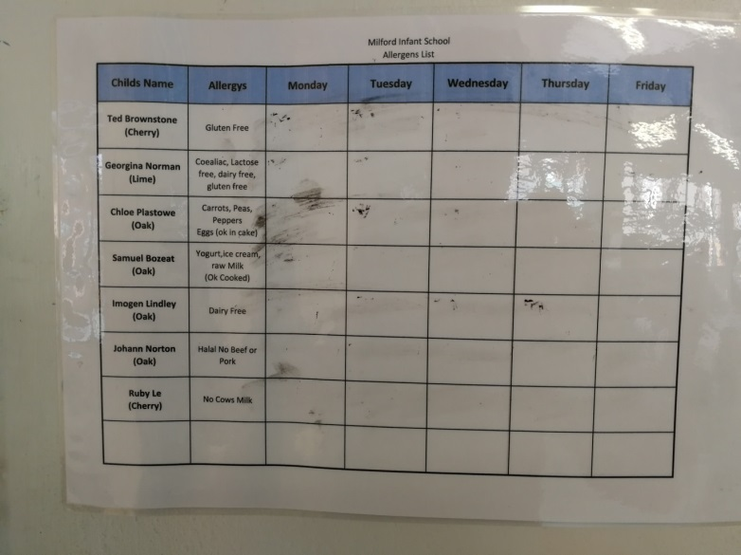
Teachers ensure that children receive the correct wristband to correspond to their parent’s food choice for each day. If teachers are unsure, they will always speak to the office and kitchen before leaving children in the school hall for lunch.
Kitchen staff will always check if a child is querying any meal choice being given to them by looking at the information provided and/or speaking to the school office before giving a meal.

